Multi-Tile Tessellation
# Source: AI Source: Provided by: [Data Path: Persons Table -> ID Column: 1, Name_En Column: Motasem Essam] -> From: [ChatGPT] on [7/25/2026]
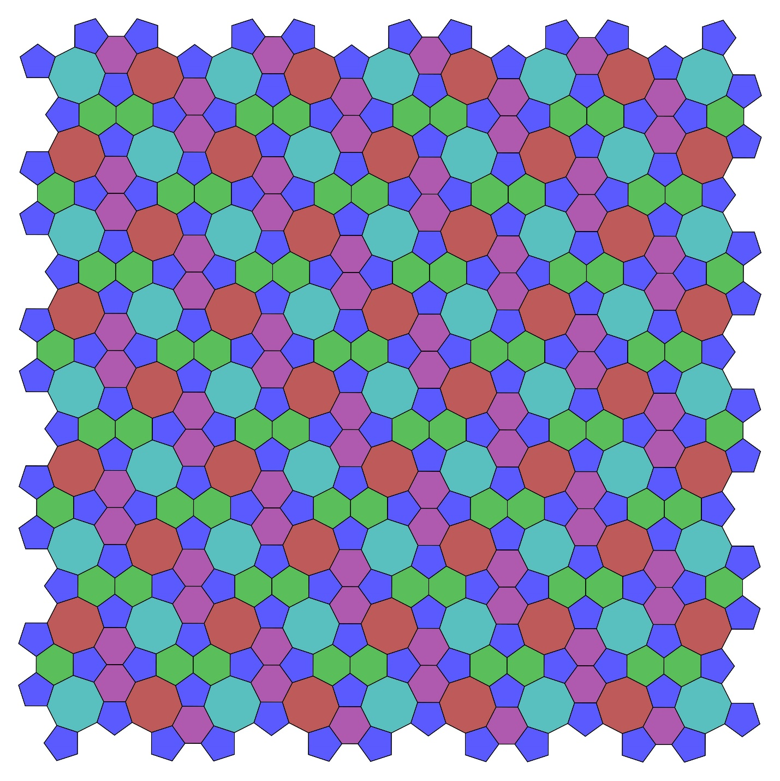
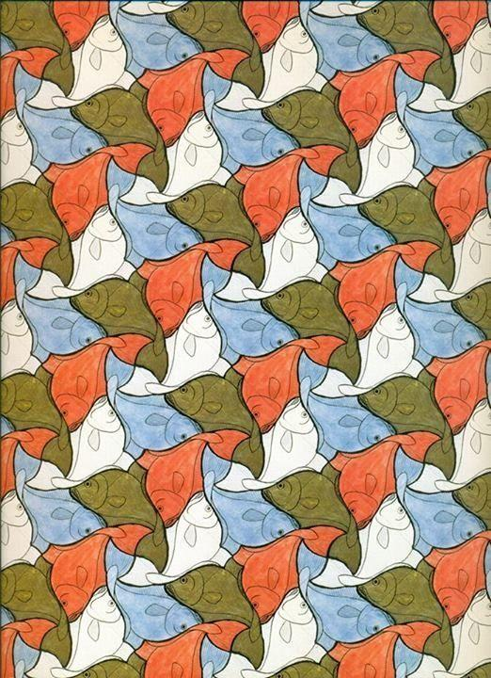
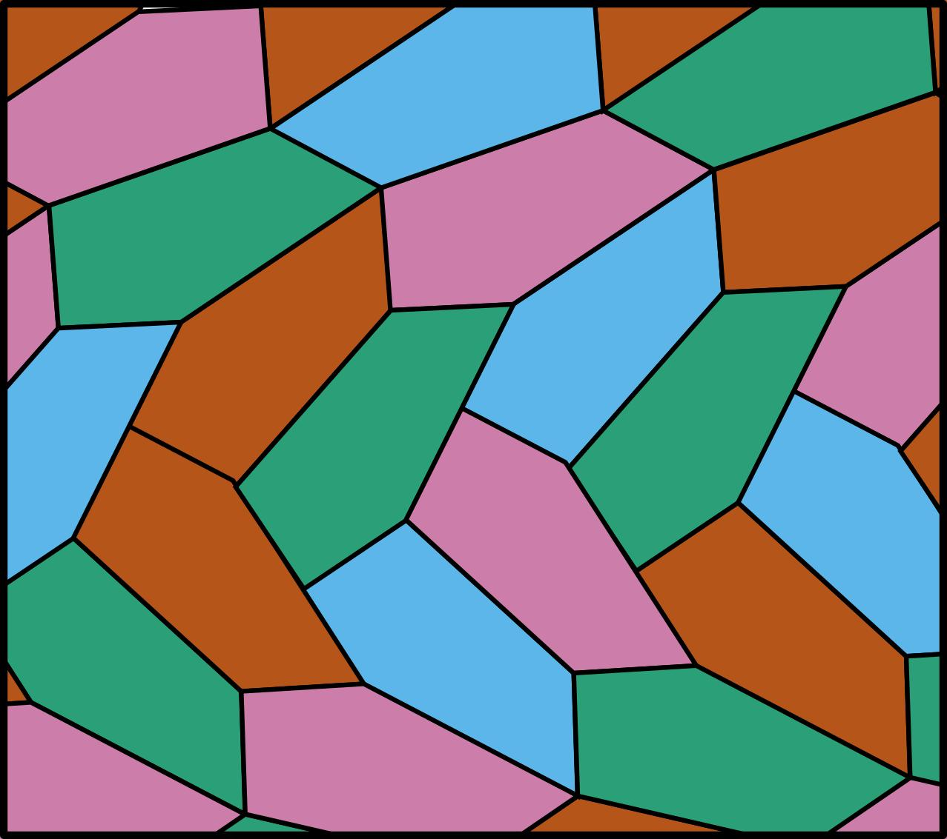
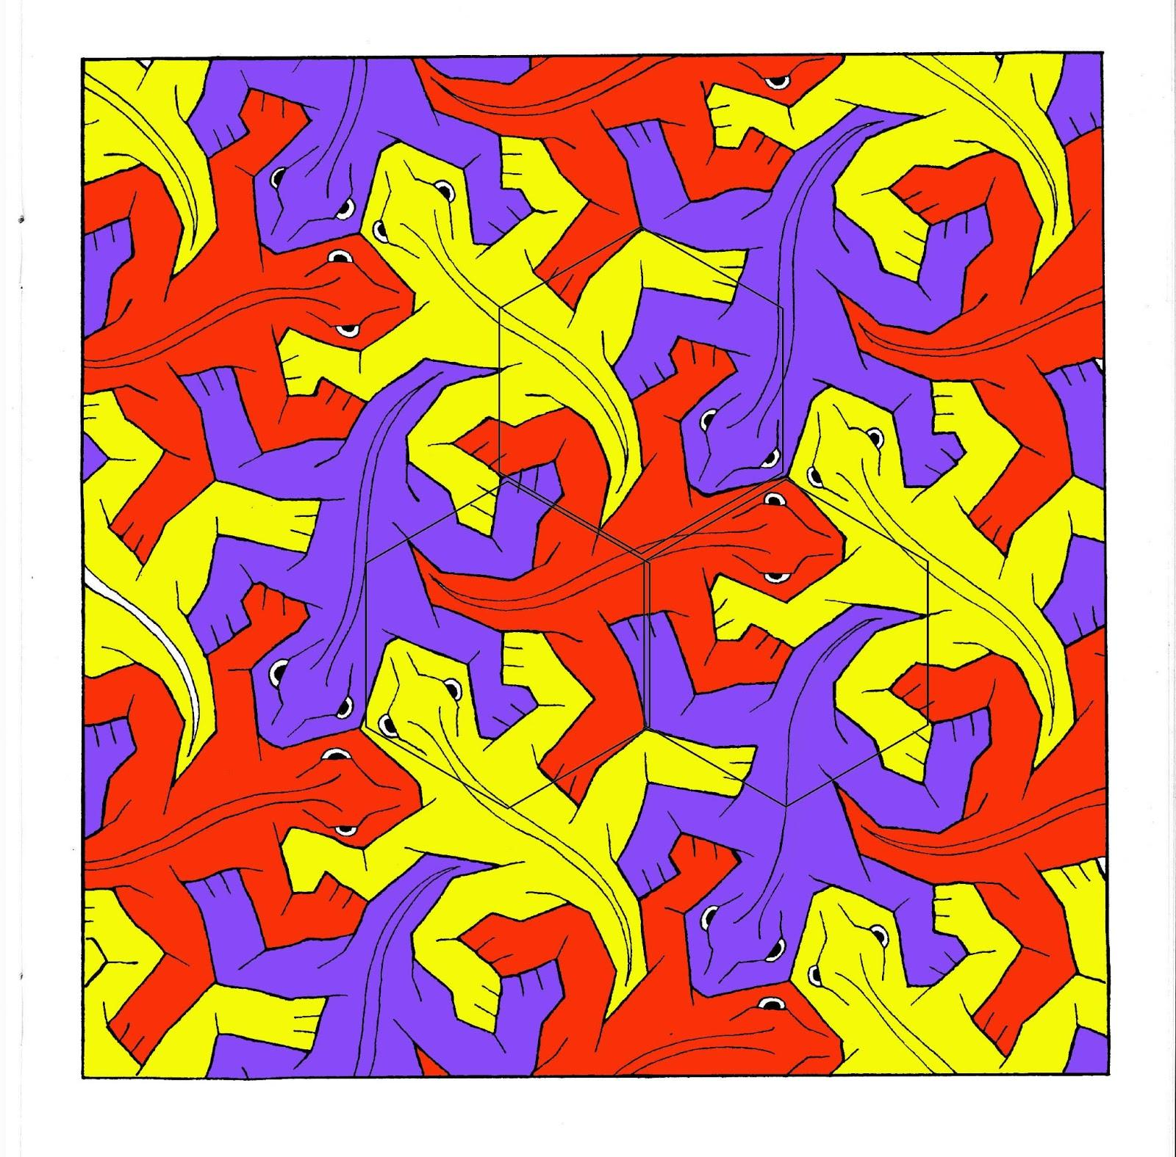
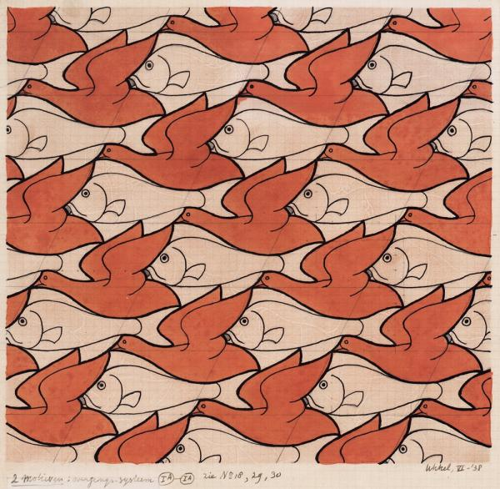
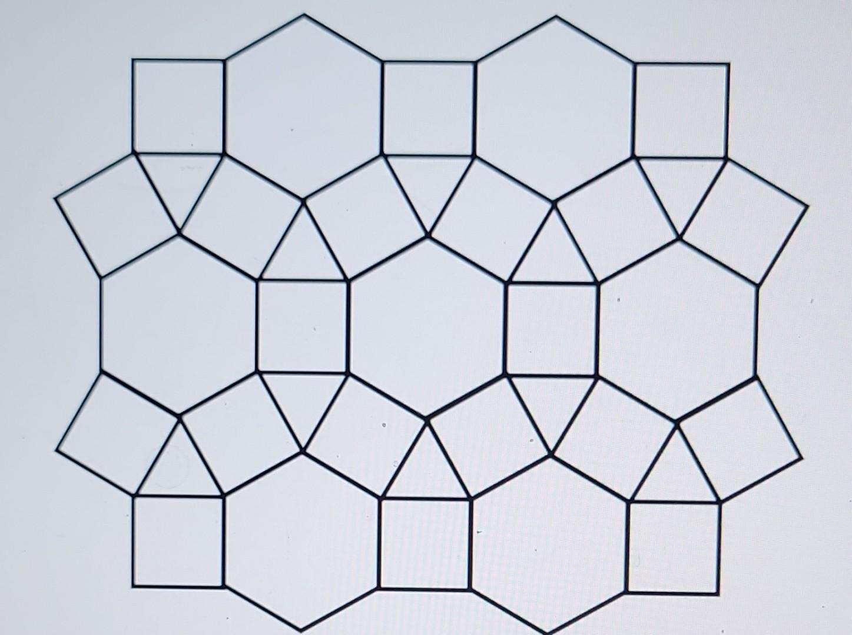

Definition
# Source: AI Source: Provided by: [Data Path: Persons Table -> ID Column: 1, Name_En Column: Motasem Essam] -> From: [ChatGPT] on [7/25/2026]
A Multi-Tile Tessellation is a tessellation that uses two or more different tile shapes to completely cover a plane without gaps or overlaps.
In terms of prototiles:
$$\boxed{\text{Multi-Tile Tessellation}=\text{2 or more prototile shapes}}$$
A tessellation may contain multiple geometric shapes, and irregular tessellations can use irregular polygons, polyominoes, or other geometric shapes. (Wikipedia)
For your classification, Multi-Tile Tessellation refers specifically to an irregular tessellation whose tiles come from multiple distinct tile shapes.

Basic Structure
# Source: AI Source: Provided by: [Data Path: Persons Table -> ID Column: 1, Name_En Column: Motasem Essam] -> From: [ChatGPT] on [7/25/2026]
A multi-tile tessellation can be represented as:
$$\boxed{A+B+C+⋯→\text{Complete Plane}}$$
For example:
Tile A + Tile B + Tile C
→ repeated and arranged
→ no gaps
→ no overlaps
→ complete plane coverage
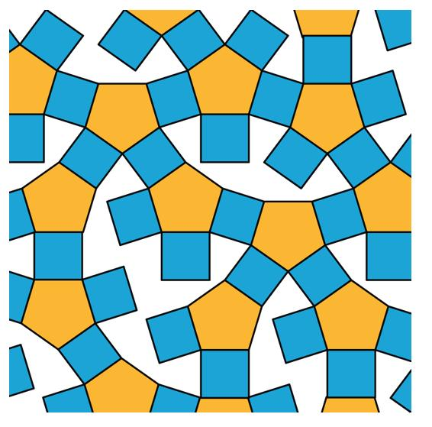
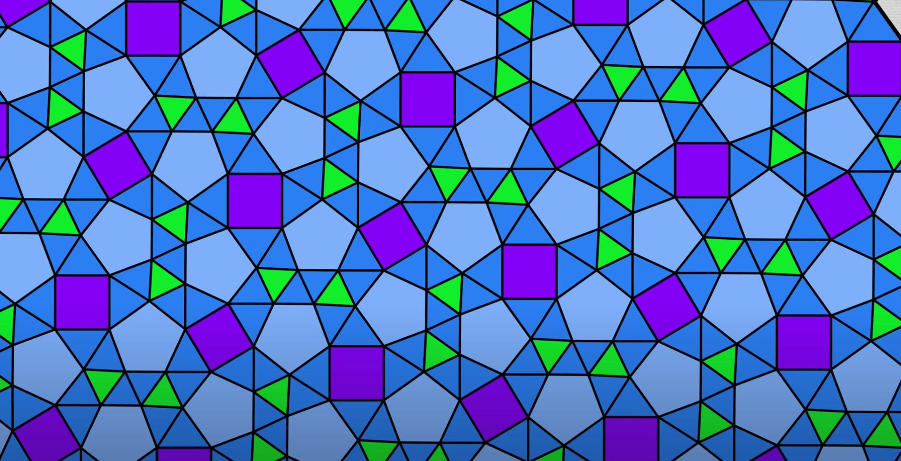
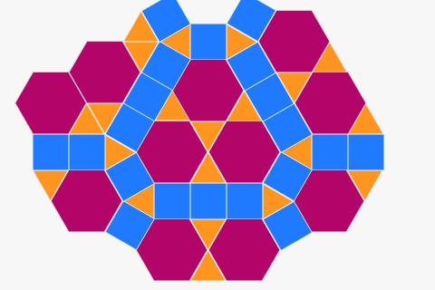
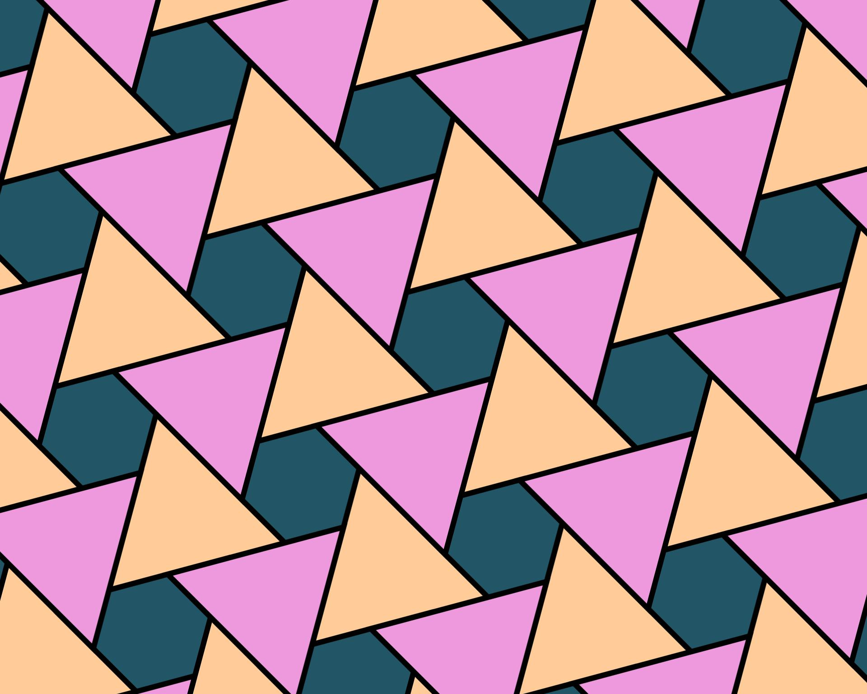
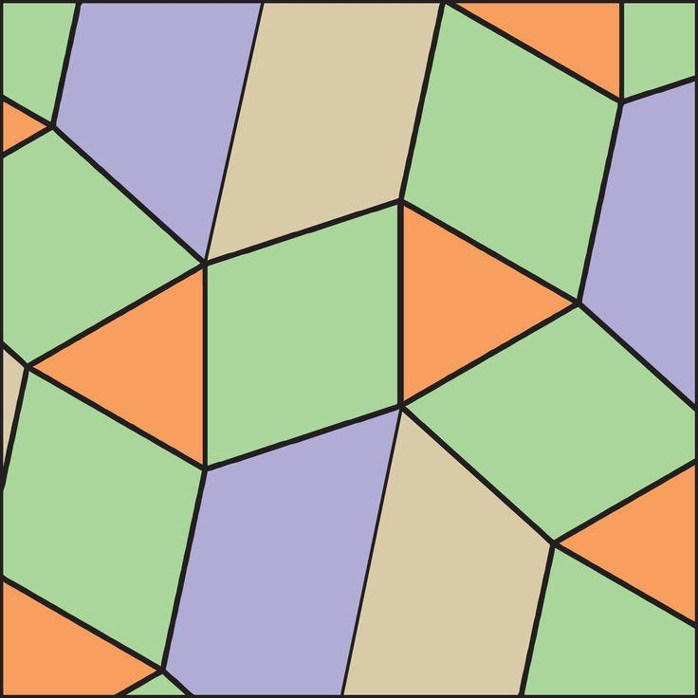

Why Is It Called "Multi-Tile"?
# Source: AI Source: Provided by: [Data Path: Persons Table -> ID Column: 1, Name_En Column: Motasem Essam] -> From: [ChatGPT] on [7/25/2026]
The term multi-tile emphasizes that the tessellation contains more than one distinct prototile.
For example:
One-tile tessellation
$$\boxed{A+A+A+A+⋯}$$
Only one basic tile shape is used.
This corresponds to a monotile / monohedral tessellation when all tiles are congruent copies of one prototile. (Wikipedia)
Multi-tile tessellation
$$\boxed{A+B+A+C+B+A+⋯}$$
Two or more different prototile shapes are used.

Example
# Source: AI Source: Provided by: [Data Path: Persons Table -> ID Column: 1, Name_En Column: Motasem Essam] -> From: [ChatGPT] on [7/25/2026]
Imagine a tessellation containing:
- 🔺 irregular triangle
- ◼️ irregular quadrilateral
- ⬟ irregular pentagon
The pattern might contain:
$$\boxed{△+□+\text{\backslash pentagon}+△+□+\text{\backslash pentagon}+⋯}$$
If these shapes completely cover the plane without gaps or overlaps, they form a multi-tile tessellation.
The shapes do not need to be regular polygons. Irregular tessellations can use many different geometric shapes. (Wikipedia)

Multi-Tile Does Not Automatically Mean Irregular
# Source: AI Source: Provided by: [Data Path: Persons Table -> ID Column: 1, Name_En Column: Motasem Essam] -> From: [ChatGPT] on [7/25/2026]
This is an important classification distinction for your knowledge base.
A tessellation can use multiple tile types without being an irregular tessellation.
For example:
Semi-Regular Tessellation
The 4.8.8 tessellation uses:
- squares
- octagons
So it is a multi-tile tessellation in the broad sense.
But it is not irregular, because its tiles are regular polygons arranged according to a uniform vertex configuration.
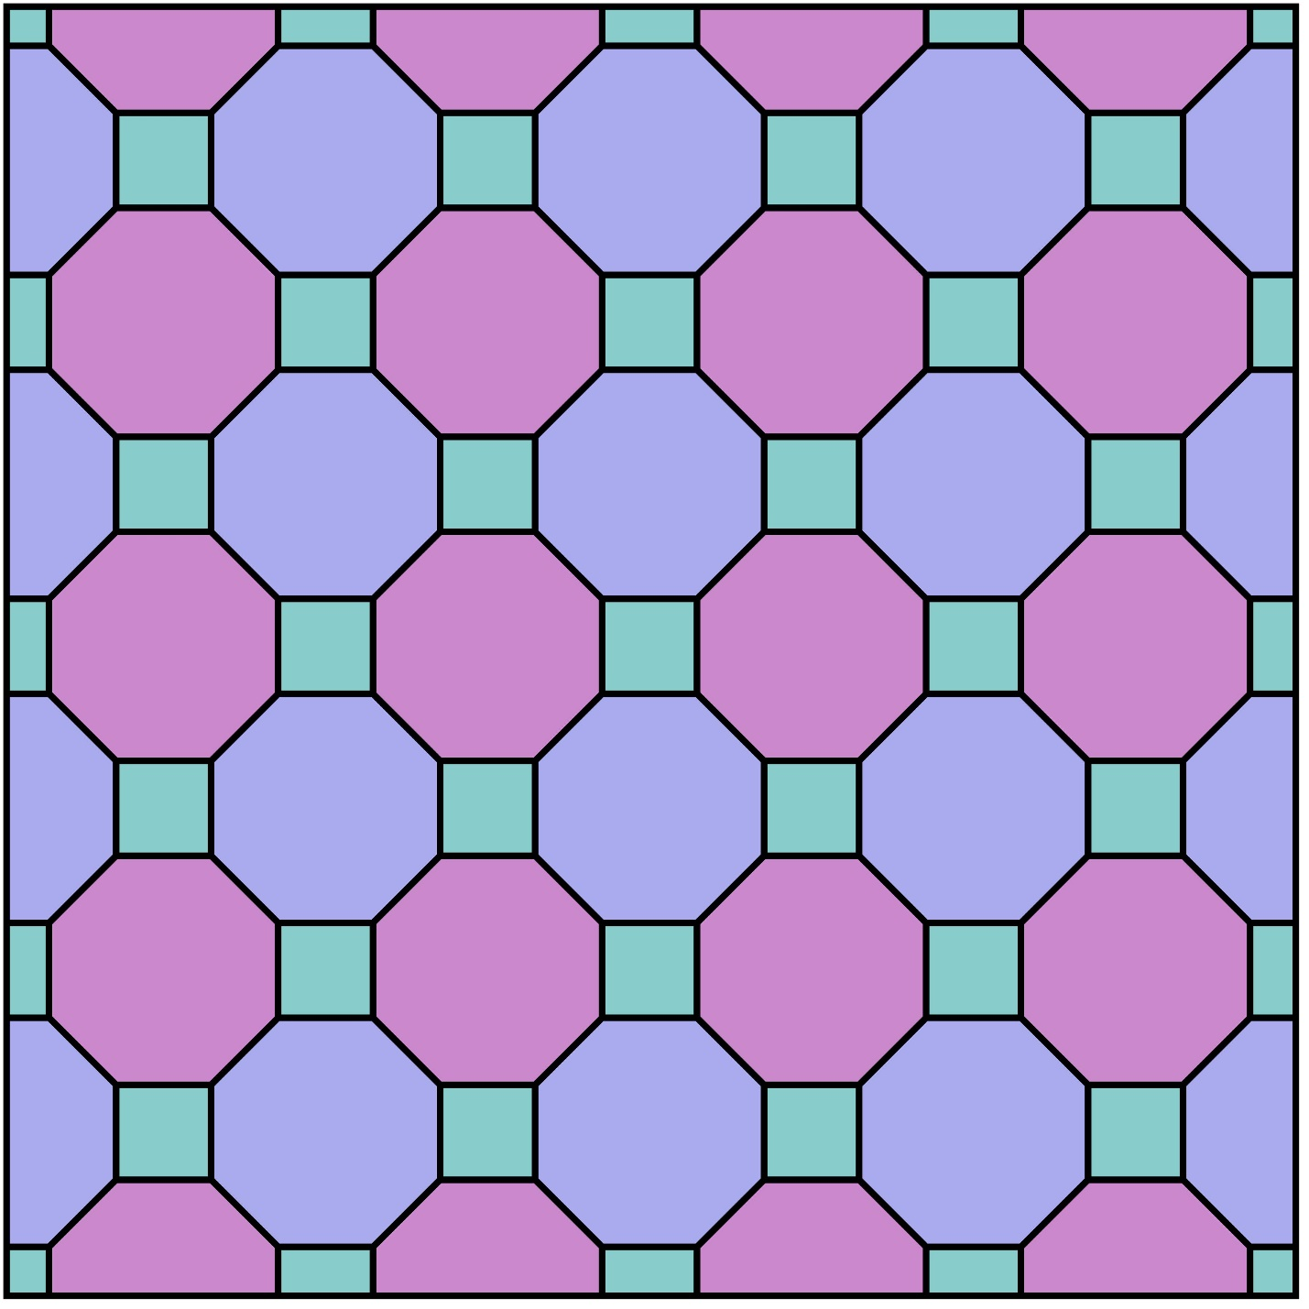
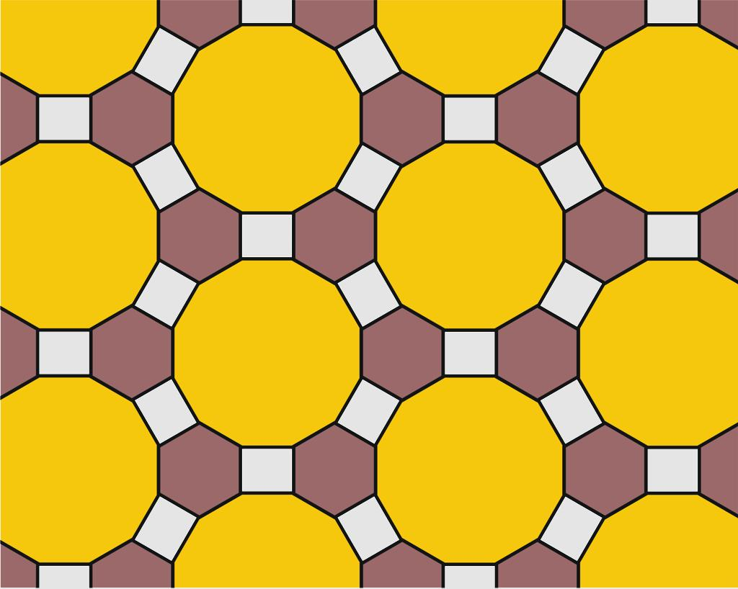
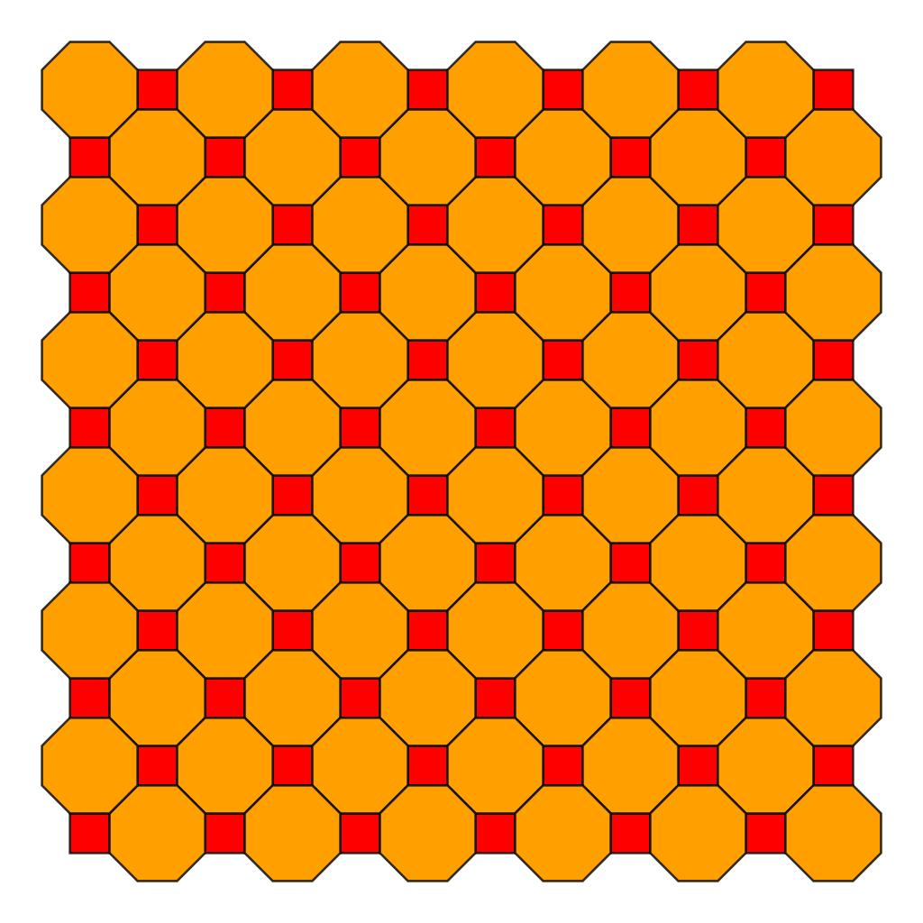
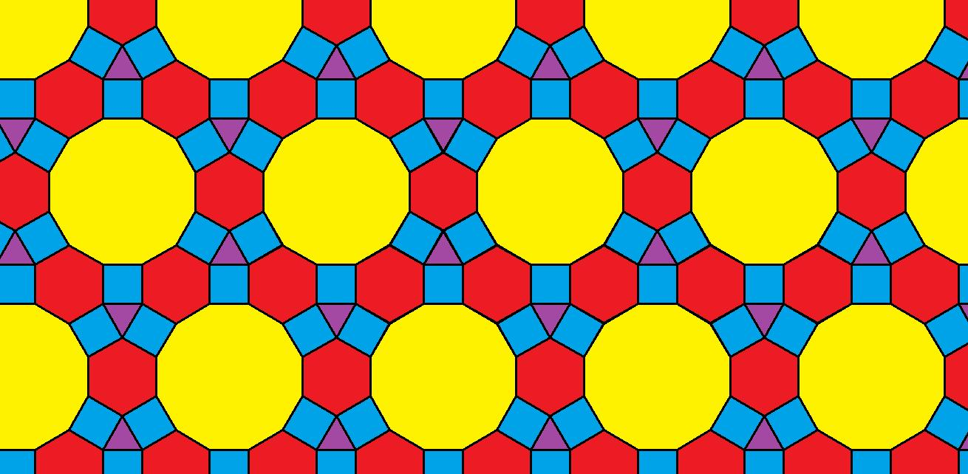
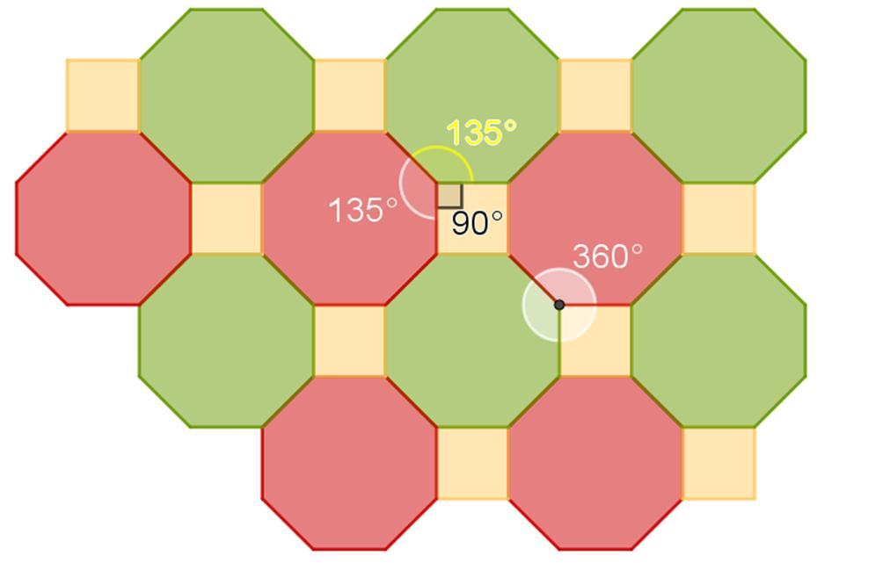
Therefore:
$$\boxed{\text{Multi-Tile}≠\text{Irregular}}$$
Multi-Tile describes the number of tile types, while Irregular describes the geometric nature/classification of the tiles and arrangement.

Multi-Tile Irregular Tessellation
# Source: AI Source: Provided by: [Data Path: Persons Table -> ID Column: 1, Name_En Column: Motasem Essam] -> From: [ChatGPT] on [7/25/2026]
For your particular category:
Irregular Tessellations
→ Multi-Tile Tessellation
the defining combination is:
$$\boxed{\text{Multiple Tile Types}+\text{Irregular Geometry}}$$
For example, an irregular tessellation could use several different irregular polygons whose sides and angles are designed to fit together.
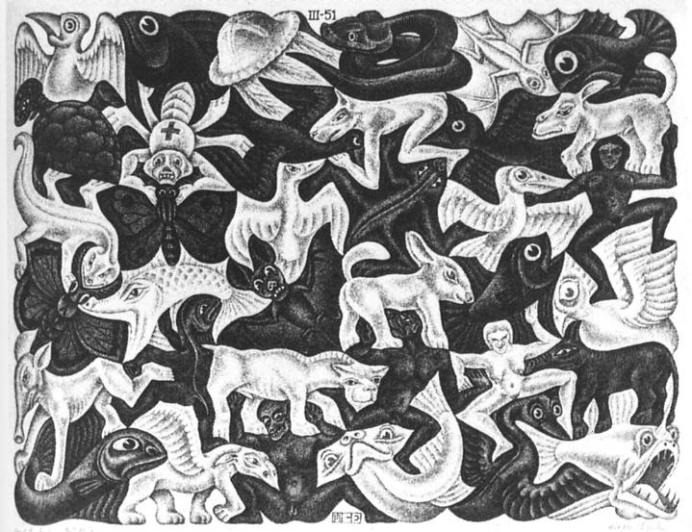
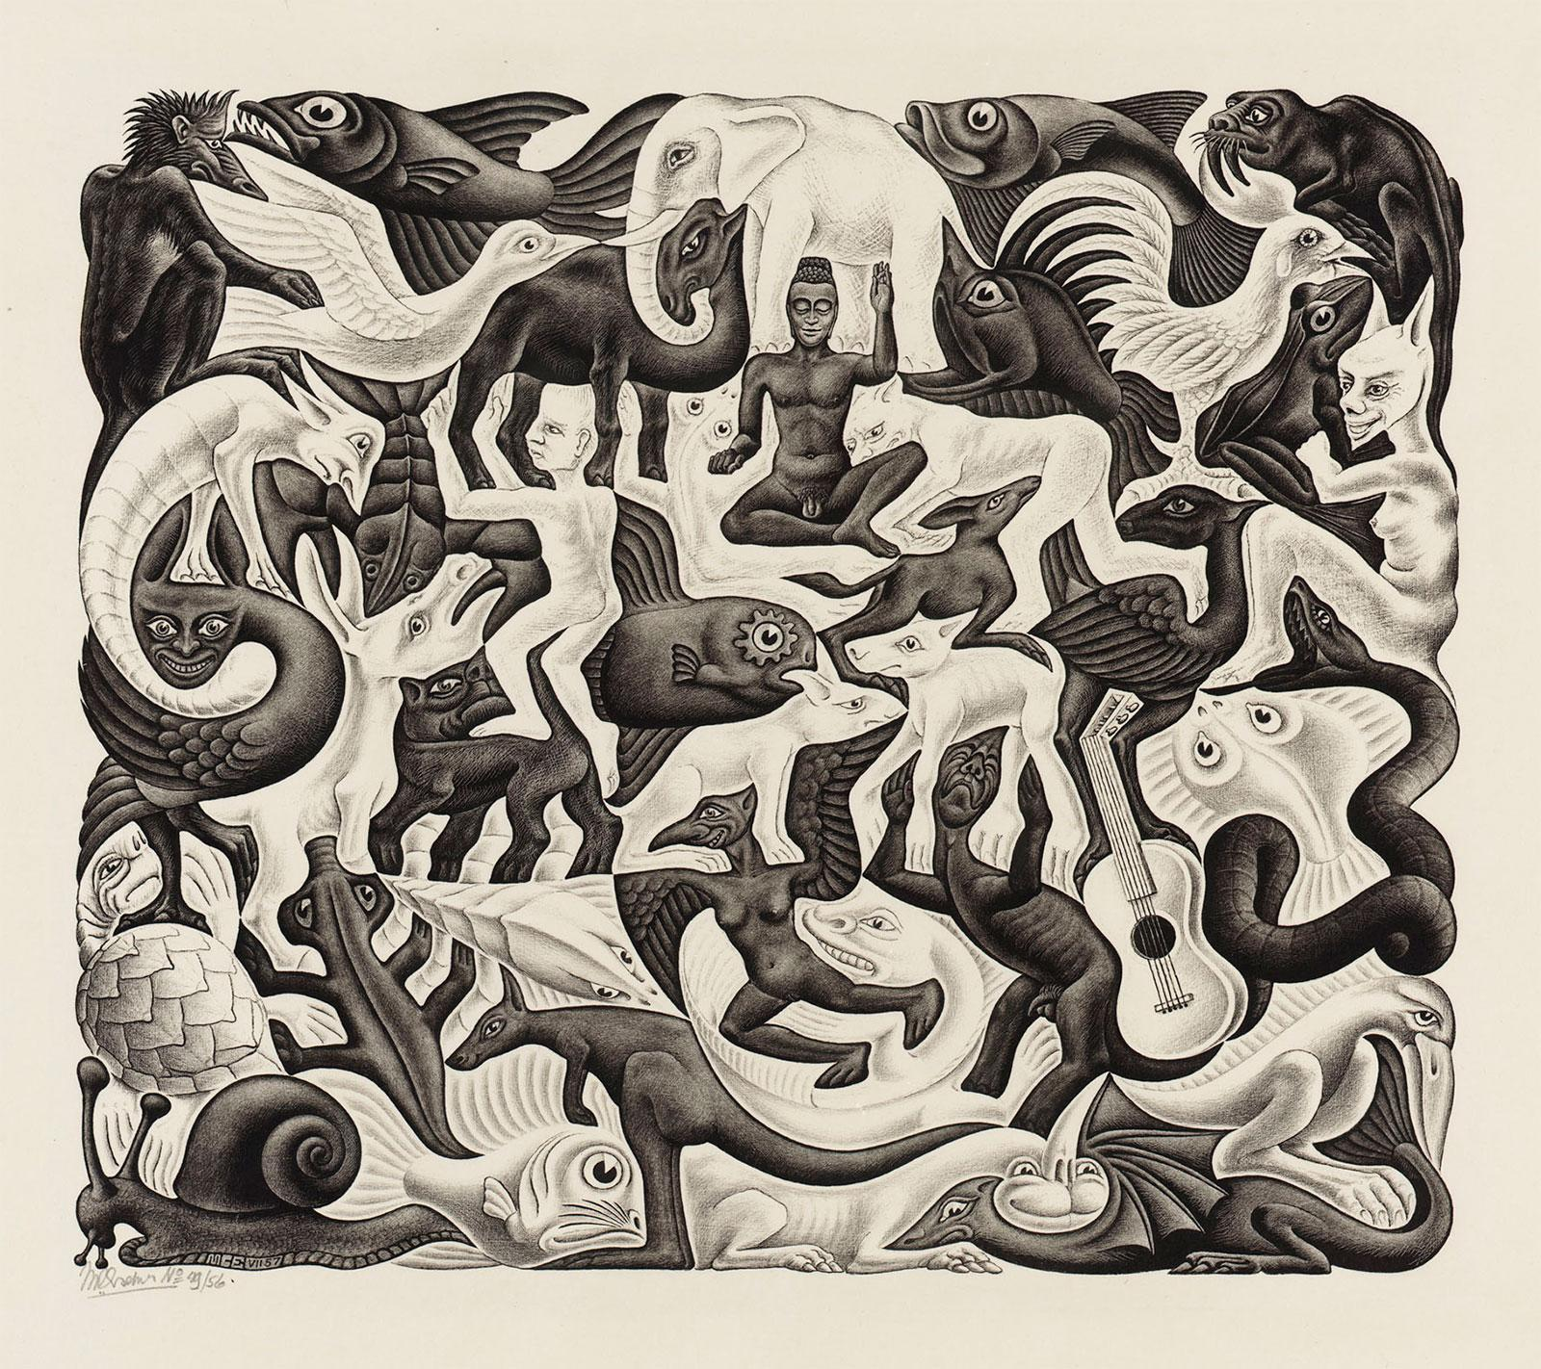
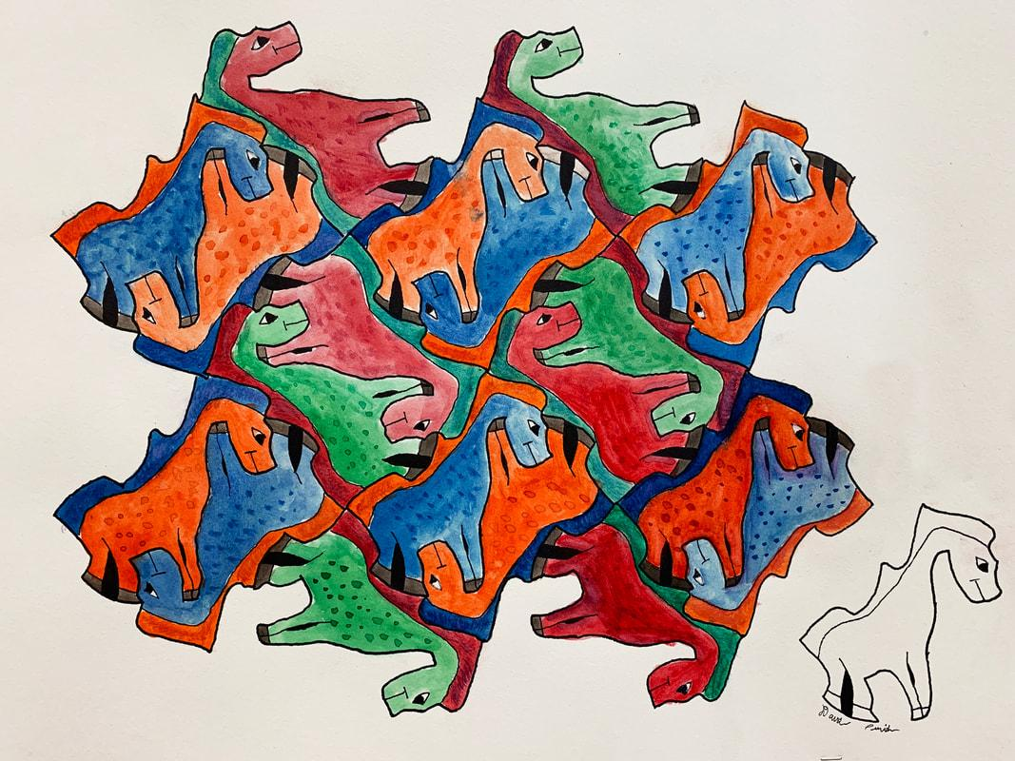
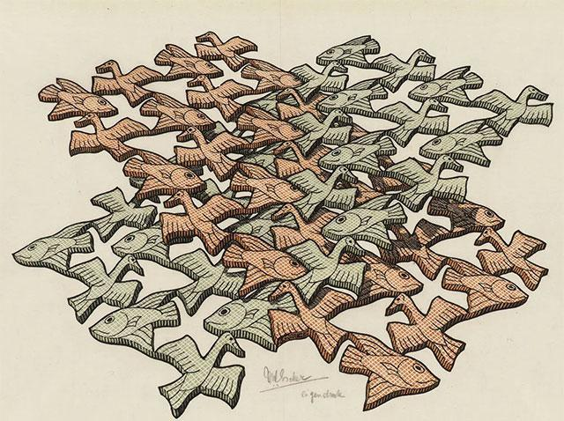
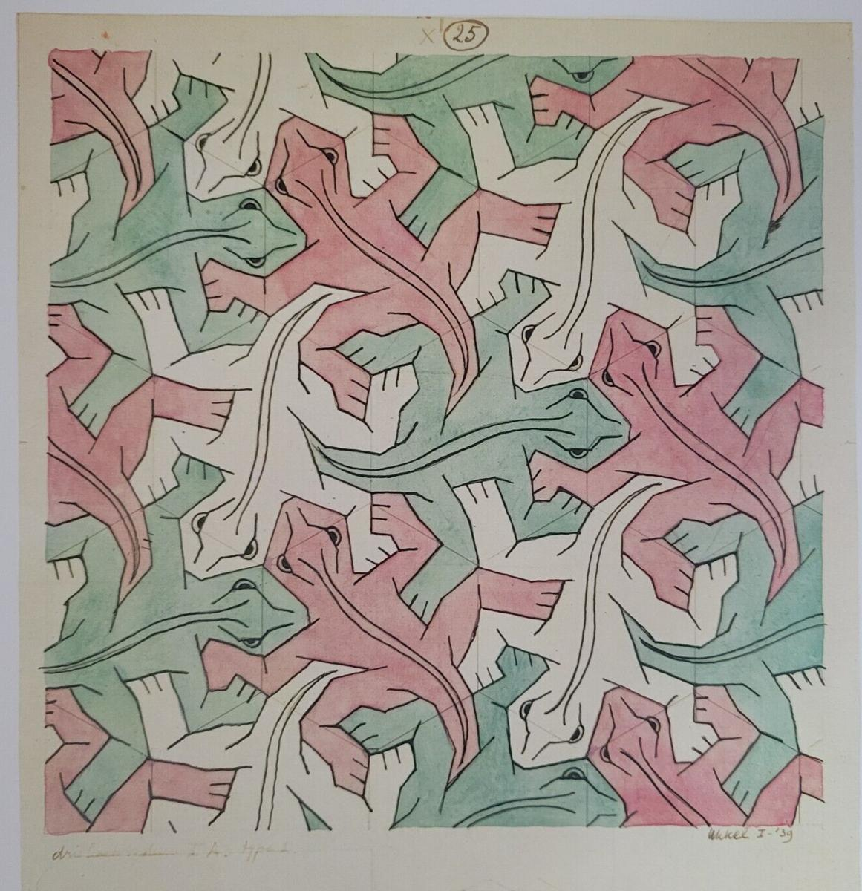
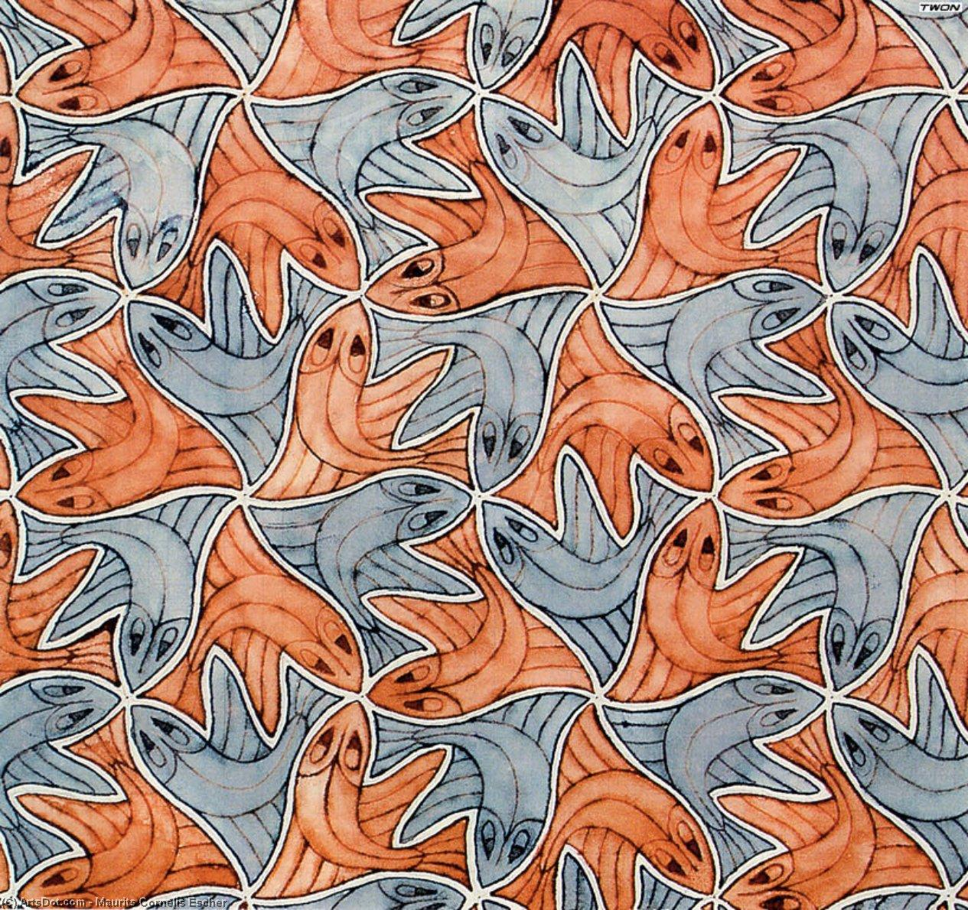

Comparison with Monotile Tessellation
# Source: AI Source: Provided by: [Data Path: Persons Table -> ID Column: 1, Name_En Column: Motasem Essam] -> From: [ChatGPT] on [7/25/2026]
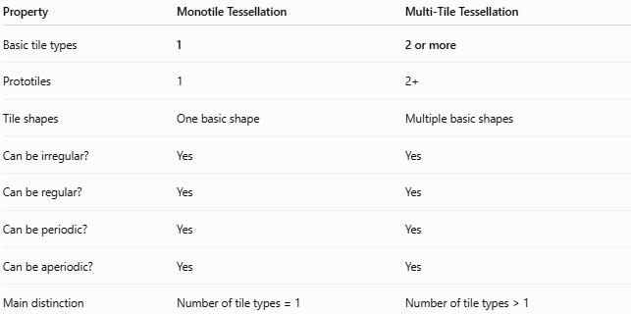
Property | Monotile Tessellation | Multi-Tile Tessellation
Basic tile types | 1 | 2 or more
Prototiles | 1 | 2+
Tile shapes | One basic shape | Multiple basic shapes
Can be irregular? | Yes | Yes
Can be regular? | Yes | Yes
Can be periodic? | Yes | Yes
Can be aperiodic? | Yes | Yes
Main distinction | Number of tile types = 1 | Number of tile types > 1
A monotile has exactly one prototile, whereas a tessellation with multiple prototiles is a multi-tile tessellation. (Wikipedia)

Comparison with Semi-Regular Tessellation
# Source: AI Source: Provided by: [Data Path: Persons Table -> ID Column: 1, Name_En Column: Motasem Essam] -> From: [ChatGPT] on [7/25/2026]
This distinction is especially important because you have already studied the semi-regular tessellations.
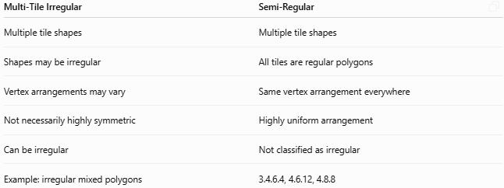
Multi-Tile Irregular | Semi-Regular
Multiple tile shapes | Multiple tile shapes
Shapes may be irregular | All tiles are regular polygons
Vertex arrangements may vary | Same vertex arrangement everywhere
Not necessarily highly symmetric | Highly uniform arrangement
Can be irregular | Not classified as irregular
Example: irregular mixed polygons | 3.4.6.4, 4.6.12, 4.8.8
For example:
$$\boxed{3.4.6.4}$$
contains triangles, squares, and hexagons, but all three are regular polygons, and the same configuration occurs at every vertex. Therefore it is semi-regular, not an irregular multi-tile tessellation. (Math Is Fun)

Classification
# Source: AI Source: Provided by: [Data Path: Persons Table -> ID Column: 1, Name_En Column: Motasem Essam] -> From: [ChatGPT] on [7/25/2026]
For your Plane Geometry knowledge base, I recommend:
Tessellations
→ Irregular Tessellations
→ Multi-Tile Tessellation
And alongside it:
Tessellations
→ Irregular Tessellations
→ Monotile Tessellation
The distinction is:
$$\boxed{\text{Monotile}=1\text{ prototile}} \\ \boxed{\text{Multi-Tile}=2+\text{ prototiles}}$$
This gives your classification a clear structural basis.

Properties
# Source: AI Source: Provided by: [Data Path: Persons Table -> ID Column: 1, Name_En Column: Motasem Essam] -> From: [ChatGPT] on [7/25/2026]
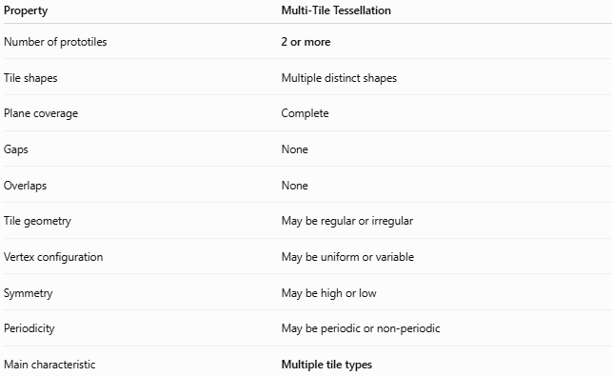
Property | Multi-Tile Tessellation
Number of prototiles | 2 or more
Tile shapes | Multiple distinct shapes
Plane coverage | Complete
Gaps | None
Overlaps | None
Tile geometry | May be regular or irregular
Vertex configuration | May be uniform or variable
Symmetry | May be high or low
Periodicity | May be periodic or non-periodic
Main characteristic | Multiple tile types

Important Terminology
# Source: AI Source: Provided by: [Data Path: Persons Table -> ID Column: 1, Name_En Column: Motasem Essam] -> From: [ChatGPT] on [7/25/2026]
Tile
An individual shape appearing in the tessellation.
Prototile
A basic shape representing one tile type. If two tiles are congruent copies of the same basic shape, they belong to the same prototile type. (Wikipedia)
Monotile
A tessellation with:
$$\boxed{1\text{ prototile}}$$
Multi-Tile
A tessellation with:
$$\boxed{2+\text{ prototiles}}$$
Tessellation
A complete covering of the plane with no gaps or overlaps. (Math Is Fun)

Key Points
# Source: AI Source: Provided by: [Data Path: Persons Table -> ID Column: 1, Name_En Column: Motasem Essam] -> From: [ChatGPT] on [7/25/2026]
- Multi-Tile Tessellation uses two or more distinct tile types.
- It is the opposite of a monotile with respect to the number of prototiles.
- The different tiles may have different shapes, sizes, or geometric structures.
- In an irregular multi-tile tessellation, the tile shapes are not restricted to regular polygons.
- The tiles must still cover the plane without gaps or overlaps.
- Multi-tile does not automatically mean irregular.
- Semi-regular tessellations are also multi-tile in the broad sense, but their tiles are regular polygons.
- Monotile vs Multi-Tile is a classification based on the number of prototiles.
- Regular / Semi-Regular / Irregular is a different classification based on the geometric properties and arrangement of the tiles.

Conclusion
# Source: AI Source: Provided by: [Data Path: Persons Table -> ID Column: 1, Name_En Column: Motasem Essam] -> From: [ChatGPT] on [7/25/2026]
$$\boxed{\text{Multi-Tile Tessellation}=\text{Tessellation using 2 or more distinct prototile shapes}}$$
For your specific category:
$$\boxed{\text{Irregular Tessellations}→\text{Multi-Tile Tessellation}}$$
means an irregular tessellation constructed from multiple different tile shapes, rather than repeatedly using only one basic tile.

